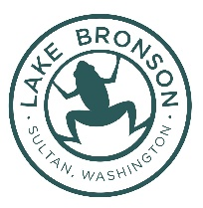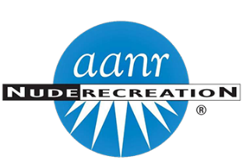
2026 AANR NW Convention July 16th – 19th 2026
Lake Bronson Family Nudist Club
33033 Cottontail Rd, Sultan, WA 98294
PO Box 1135, Sultan, WA 98294
Phone: 360-547-3190 Email: office@lakebronson.com

A full kitchen is available in the lodge for guests to use if you need to prepare your own meals. A Walk in Cooler is available for storing perishables. (No Alcohol). Ice is available at the office.
Name:___________________________________________ Email: ________________________________________
Mailing Address: __________________________________ Phone #: ______________________________________
 | Accommodations |  | ☐ | July/circle your dates | # People | # Days | Total $
 | Dry Cabins 1 – 4 | $65.94 per night | ☐ | 15 16 17 18 19 20
 | Lakeview Rooms 1 - 2 | $76.93 per night | ☐ | 15 16 17 18 19 20
2 Queen Beds | Lakeview Room 3 | $87.92 per night | ☐ | 15 16 17 18 19 20
On suite bathroom | Parkview Room 1 | $87.93 per night | ☐ | 15 16 17 18 19 20
Share bathroom | Parkview 1 – 2 | $76.93 per night | ☐ | 15 16 17 18 19 20
½ bath, Kitchenette, Dog friendly | Cottage | $120.89 per night | ☐ | 15 16 17 18 19 20
24 sites available | RV site 50/30/20 | $27.43 per night | ☐ | 15 16 17 18 19 20
Tent with bed (Bring Bedding) | Cube Tent with power | $27.43 per night | ☐ | 15 16 17 18 19 20
 | Tent site no power | $16.46 per night | ☐ | 15 16 17 18 19 20
 | Grounds Fees | $ 15.00 AANR | ☐ | 15 16 17 18 19 20
 | Grounds Fees | $20.00 Non AANR | ☐ | 15 16 17 18 19 20
 | Breakfast | Lunch | Dinner | # People
Thursday | XXXXXXXXX | XXXXXXXXX
Friday
Saturday
Sunday |  |  | On The House

Accommodations (Including grounds fees): ______________________________________Total
Check enclosed to LBA or Call the office 360-547-3190 to pay by Credit Card. (3% processing fee on Credit card payments)

